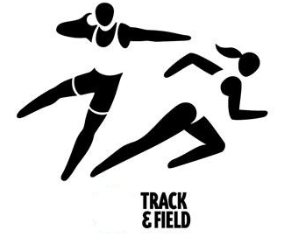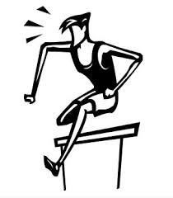

Welcome to Track & Field season at George Street Middle School!
Please note: Information pertaining to GSMS athletics can be found on the school website.
Athletic Contract: Before you can compete for George Street in a track meet, you must read and sign the athlete’s contract and return it to Mr Godin or Ms Gorman.
Fee: There is a fee of $40 this year. This will cover various costs, including supply teachers and the cost of buses to Districts in Oromocto and Provincials in Saint John.
Training schedule: We understand that many students have competing demands on their time. We expect that every member of the Track & Field team attends as many practices and mini-meets as they can manage.
Practices Tuesdays and Thursdays: All athletes will train together after school. We will meet in the gym and go to Queen’s Square Park to train. We would also like to schedule some practices at the track facilities at FHS. Please consult the website for details as they become available.
Wednesdays: Mini meets at Nashwaaksis Middle School. These meets start at 4 and usually finish around 5. Parents are responsible for transportation.
Districts are under discussion. Please consult the website for details as they become available.
Provincials will be in Saint John on June 13th. We will take a bus from the school and return to the school after the meet. Please pick up your kids at the school upon our arrival back in Fredericton. We will warn you when we are approaching Fredericton.

Thank you for your support this season!
Your coaches, Ms Chisholm and Mr Young

